First, we created Virtual private cloud (VPC) name Project-vpc with CIDR = 20.20.0.0/16 in North Virginia region(us-east-1).

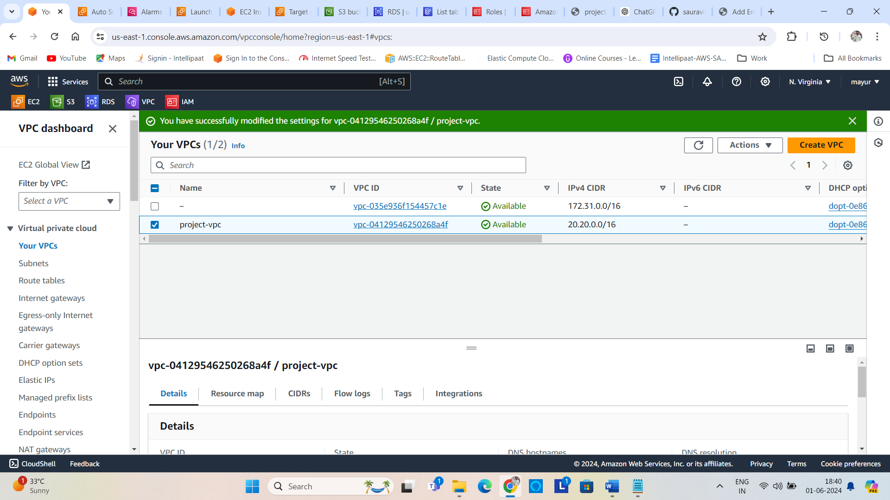

Then we created 3 subnet in the our private network (project-vpc) in AZ 1a & 1b. Those subnet are public subnet 1a ,1b & private subnet 1a in the same region North Virginia with CIDR of public subnet 1a has 20.20.1.0/24, public subnet 1b has 20.20.2.0/24 & private subnet 1a has 20.20.3.0/24.

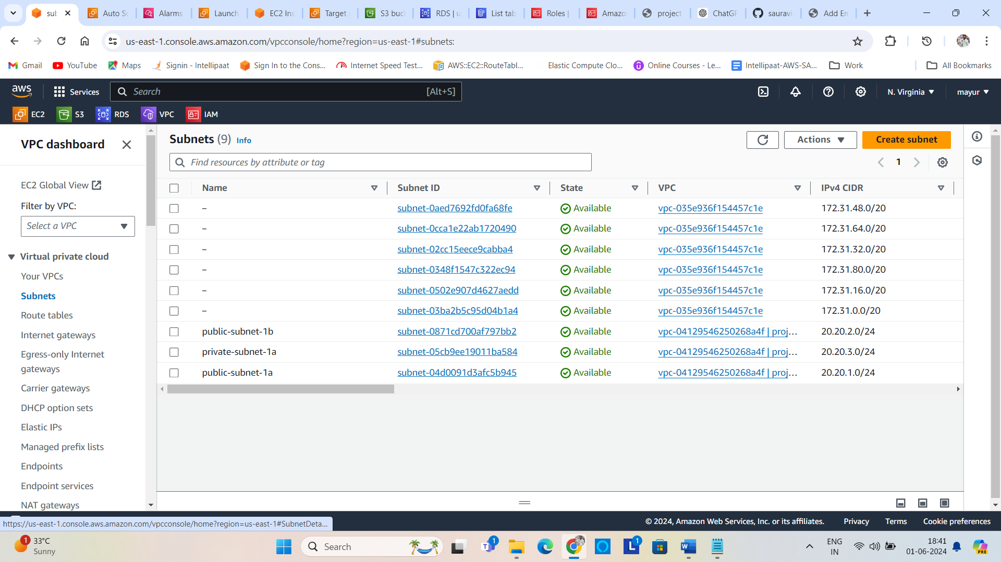

After that we created internet gateway named project-igw and attached to our private network project-vpc.

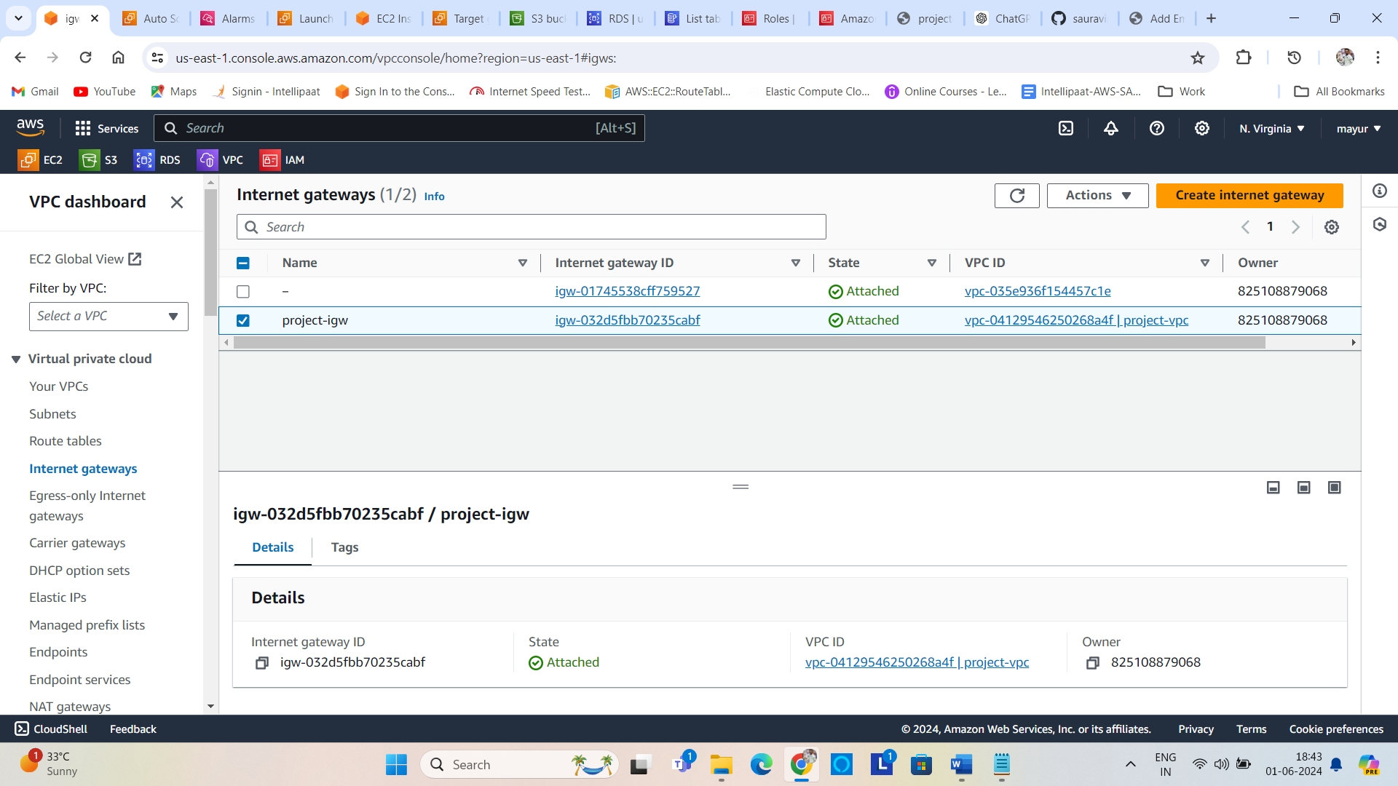

Also, I created a NAT gateway in public subnet 1a in our private network project-vpc.

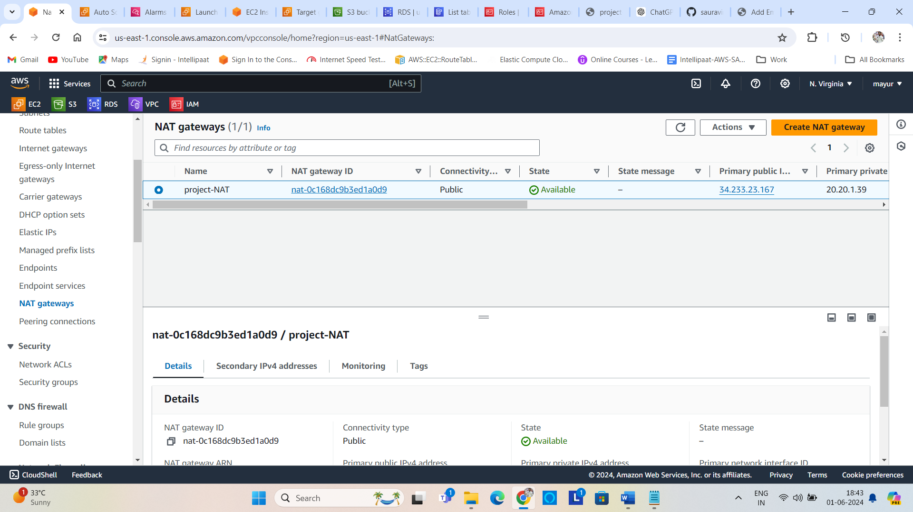

The route table created automatically at the time of the creation of project-vpc is the main route table of our private network. I consider the main route table as a public route table named public-route-project. I explicitly associated the public subnet with the public main route table as you see in the picture below.

And edit route with destination as 0.0.0.0/0 this means open to all network and target as out Internet gateway project-igw.

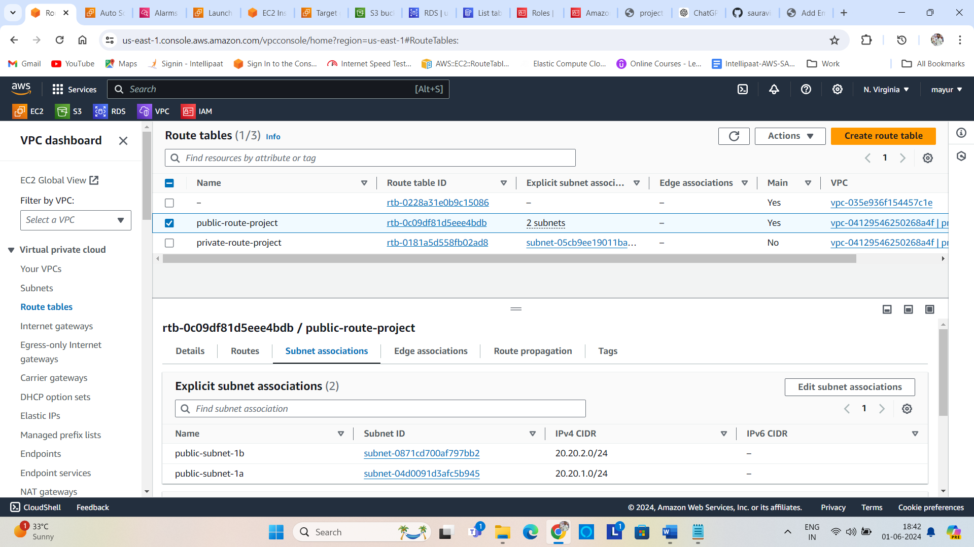

I created route table and attached to our private network(project-vpc) and explicitly attached private subnet to it as you see in below picture.

Also edited route as destination 0.0.0.0/0 which means open to all network and destination is NAT Gateway as project-NAT.

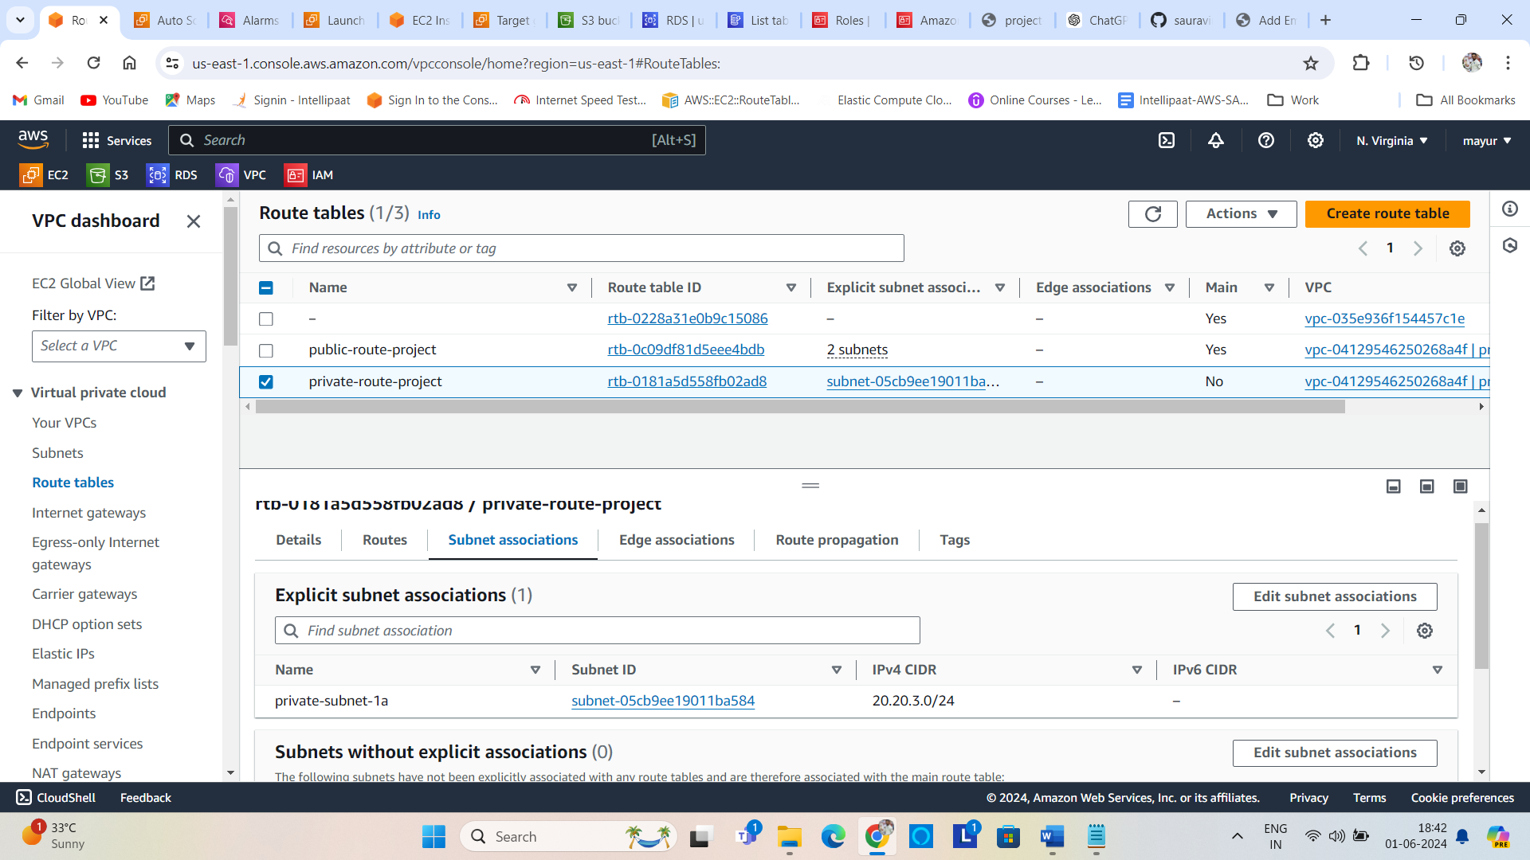

Then I created security-group for our private network named project-sg with allowing inbound traffic for SSH, HTTP and HTTP protocols. And outbound traffic is open for all traffic.

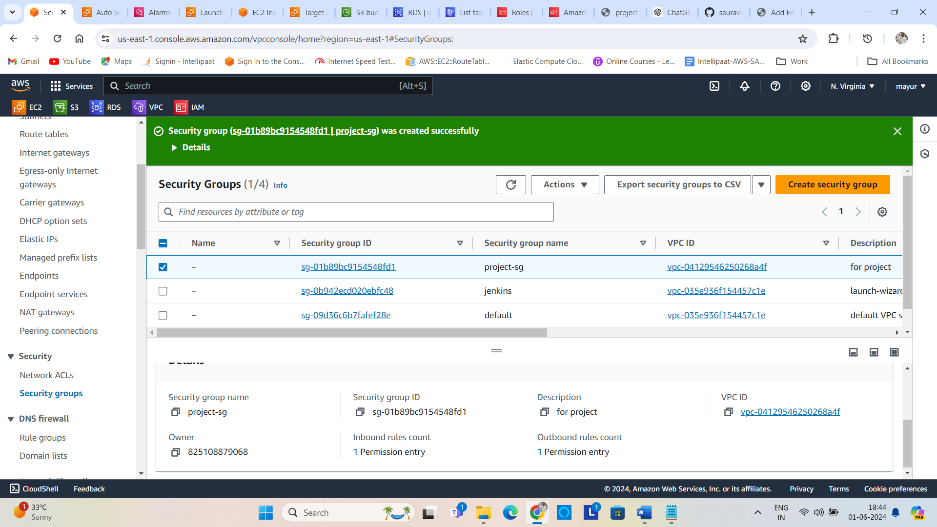

After creating all components of VPC, I created two Instances of ubuntu OS, one is public and another is private within our private network (project-vpc) attaching security group project-sg in the same North Virginia region. Name of that instances is public-project-1a and private-project-1a.

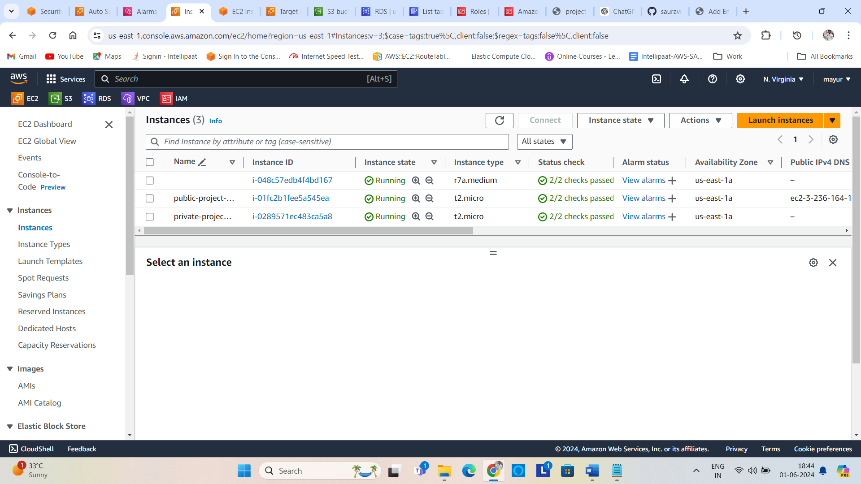

Attached Auto Scaling Group policy to the public instance public-project-1a. I created Dynamic scaling policy with simple autoscale policy.

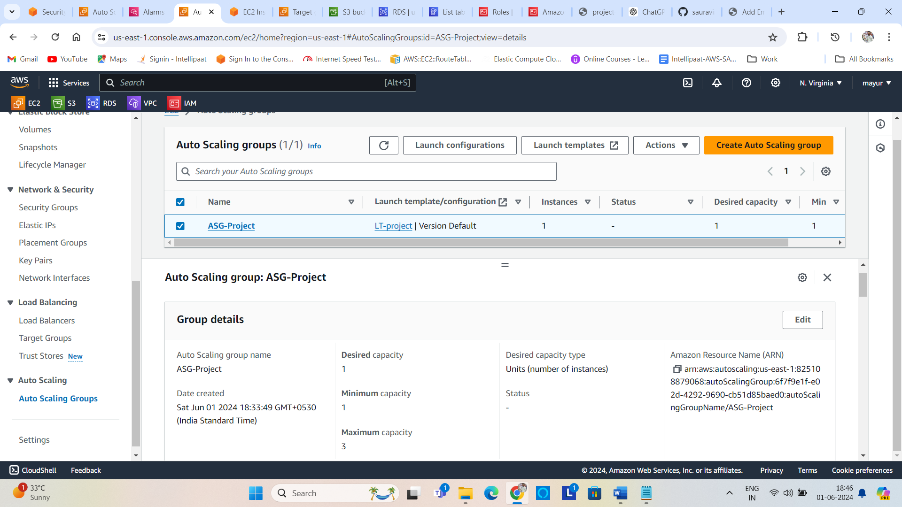

Created Application Load balancer ALB-project for internet facing. Attached our both instances under this ALB.

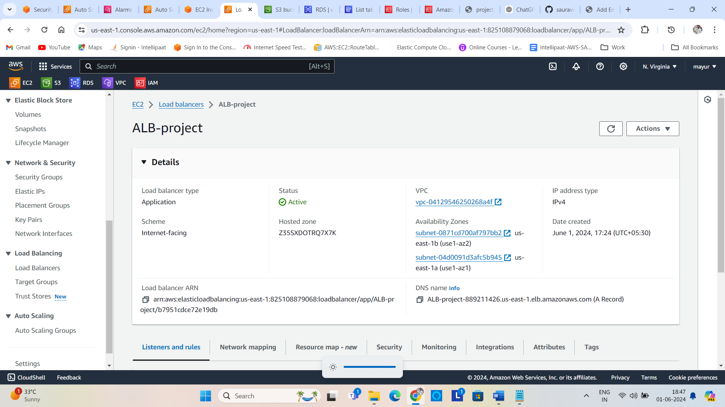

Then created an S3 bucket for object storage name project-pbunket in the same region us-east-1.

And put statice website html file in this bucket. This file shows only about us page.

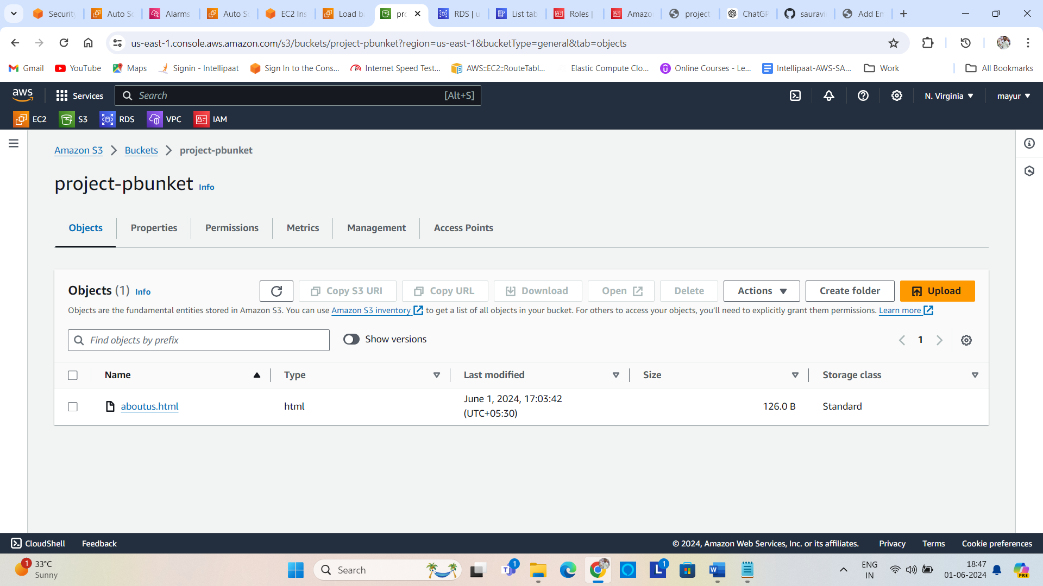

Then created a relational database (RDS) for storing the relational data. I chose the My-SQL db engine for this project and DB name is database engine name is database-1 and the database name is projectdb.

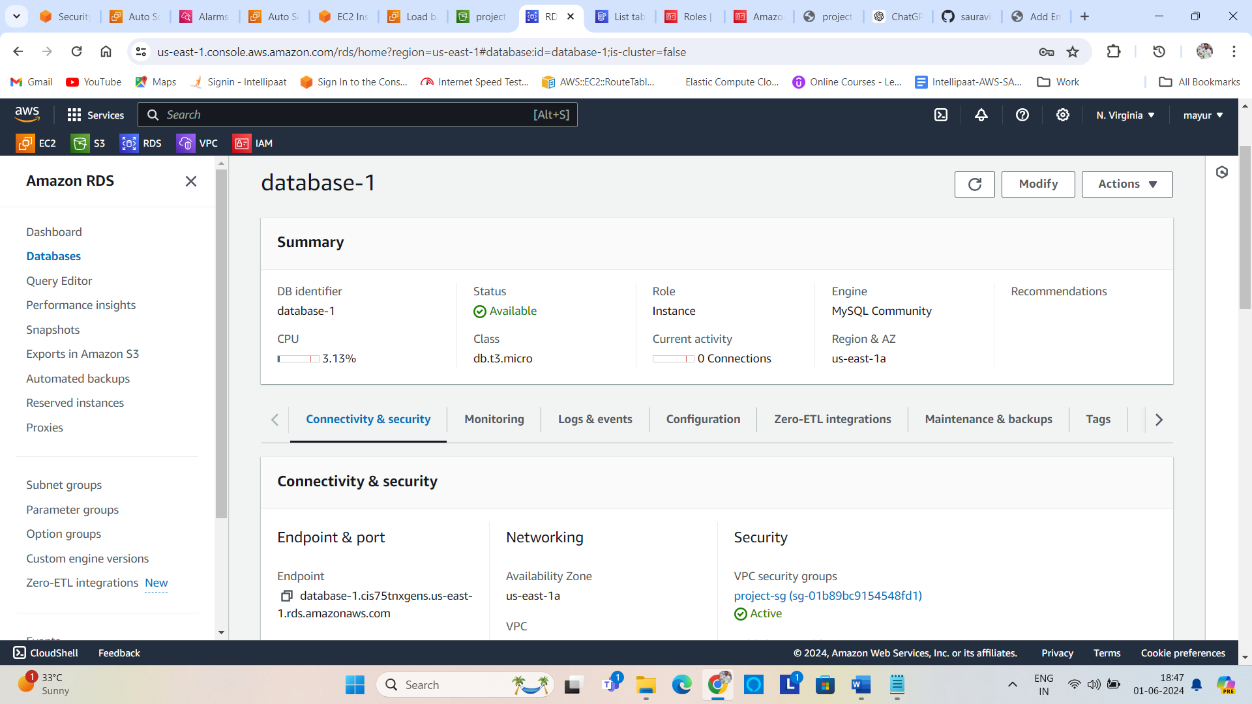

After creating S3 bucket and RDS My-SQL engine, I have created DynamoDB table named employee_image_table with partition key empid

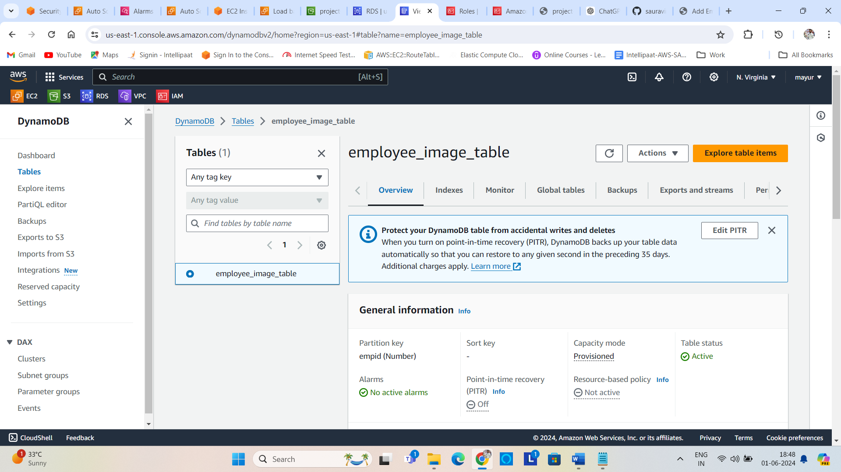

After creating all these services I created IAM role named project-final-role. I’ve attached S3, RDS, DynamoDB full access to this role. After creating this role I had attached this role to private instance.

Because no one from another network can access our services which is filled with data.

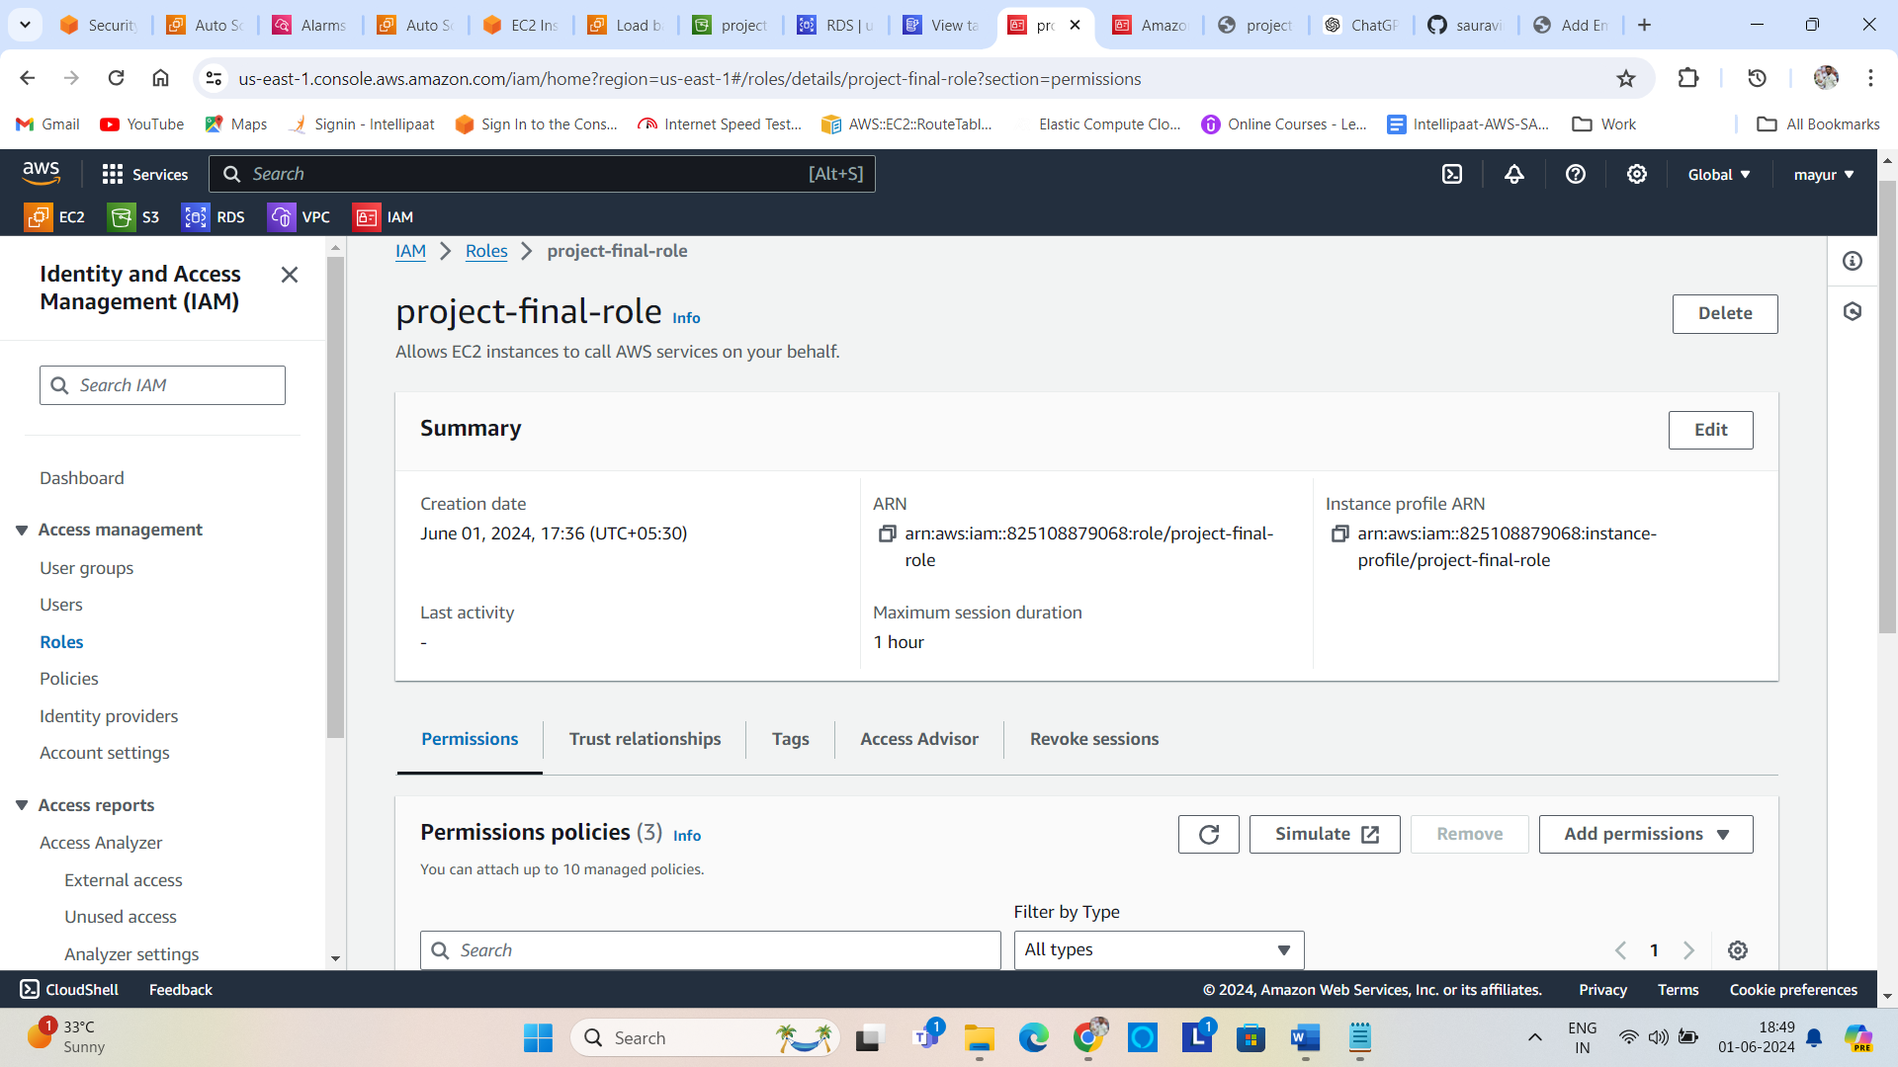

Then I had SSH into the private instance through the public instance by using the command #sudo ssh -i [ubuntu@20.20.3.0/24(private](mailto:ubuntu@20.20.3.0/24(private) ipv4 address of private instance)

After SSH into the private instance need to update this private instance by using the command

#sudo apt-get update

After that, I installed mysql-client by using the command #sudo apt-get mysql-client -y

Then I have connected to the RDS My-SQL engine by using the command # mysql -h <endpoint of the RDS engine> -u <username> -p

* <password>

Then will connect to the RDS BD by providing the data schema , created table name employee

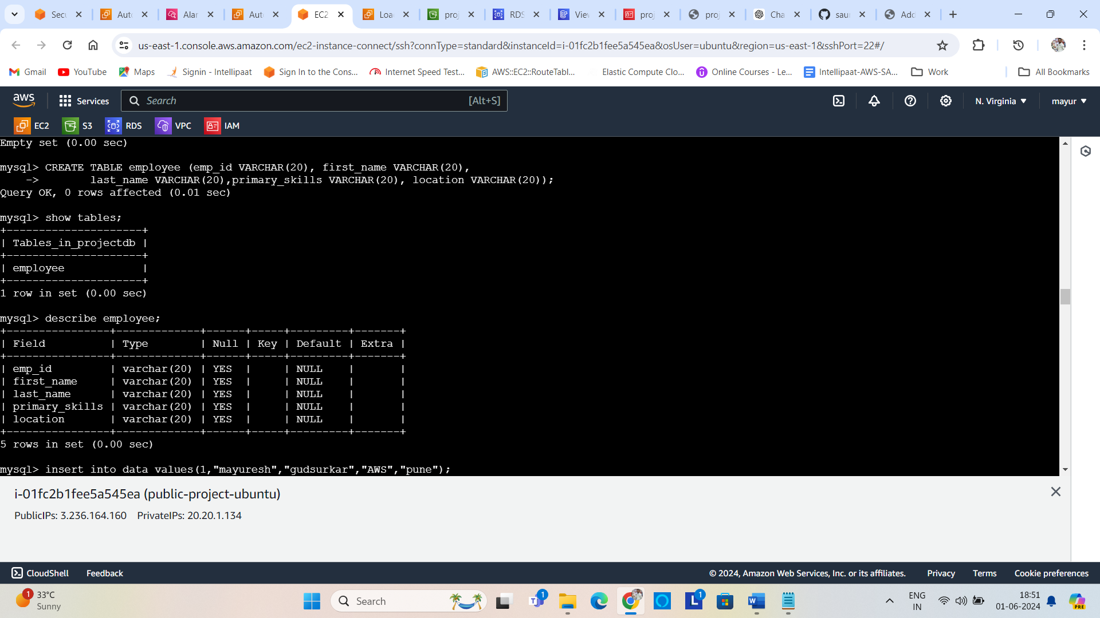

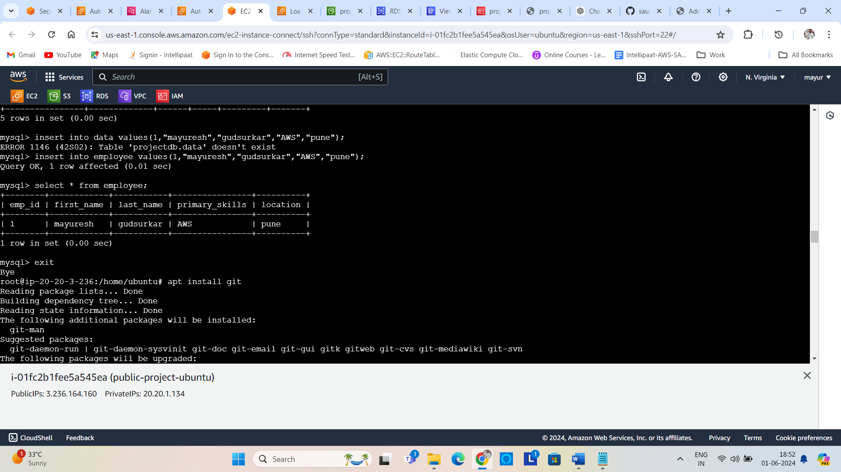

After exit from this DB.

And had to cloned some file from GitHub repository name <https://github.com/sauravinside/aws-code-main>

After cloning u can see the folder name aws-main-code , in this folder there are 5 files in it.

By providing appropriate credentials in that file we are ready to install some dependencies.

They are

# sudo apt-get install python3

# sudo apt-get install python3-flask

# sudo apt-get install python3-pymysql

# sudo apt-get install python3-boto3

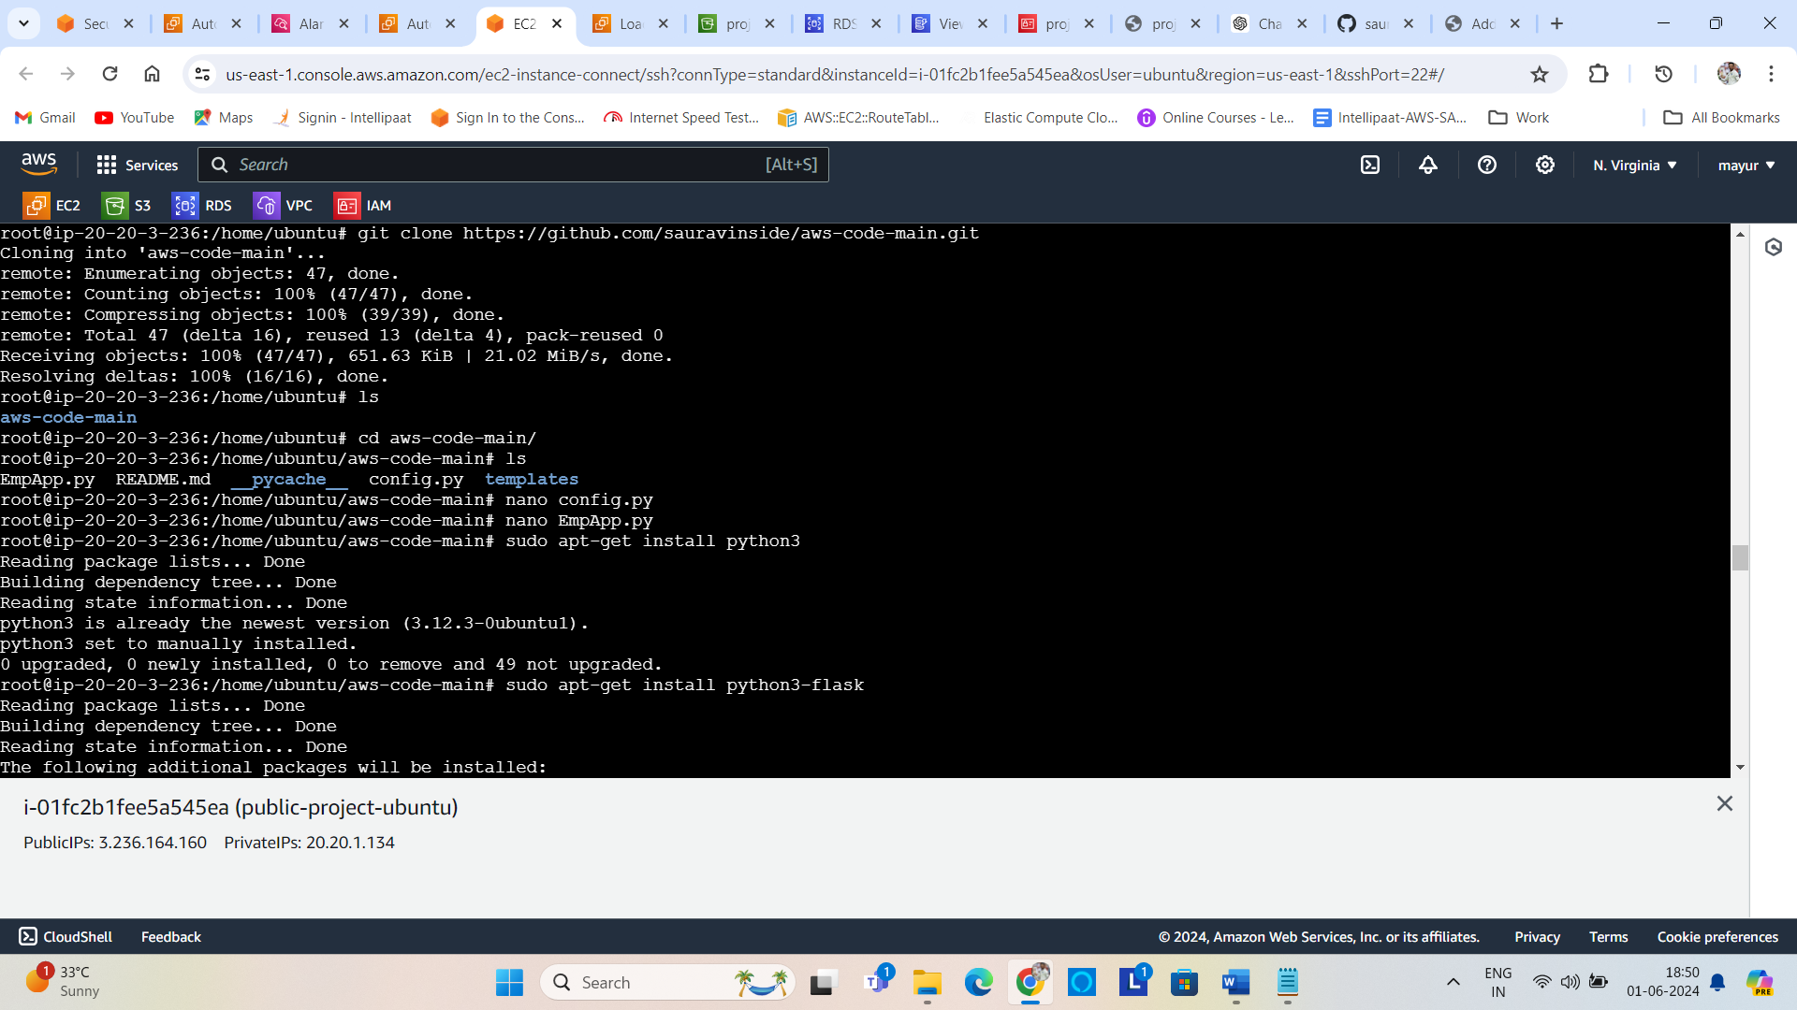

Then we started an application hitting command # sudo python3 EmpApp.py

Then by taking URL from application load balancer and paste it in the browser. We got this User interface.

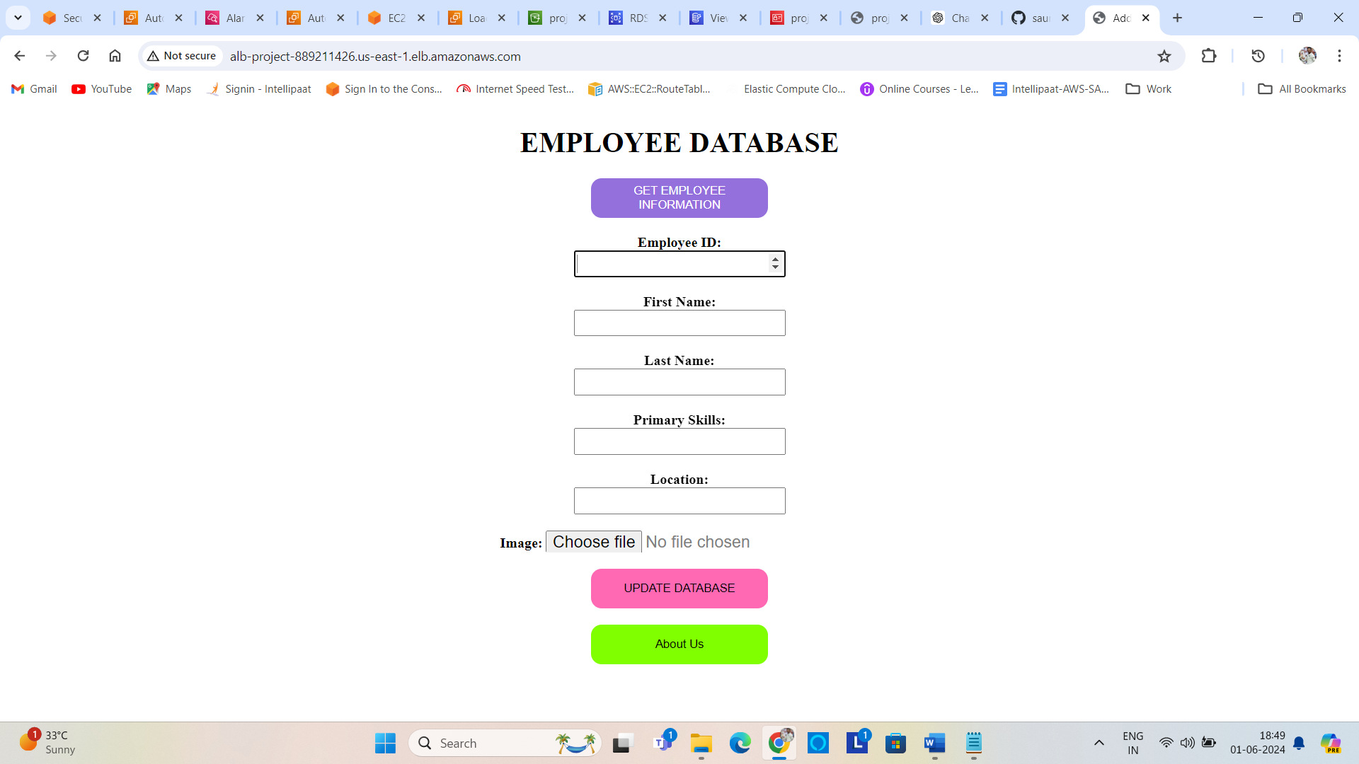

Application running in CLI mode.

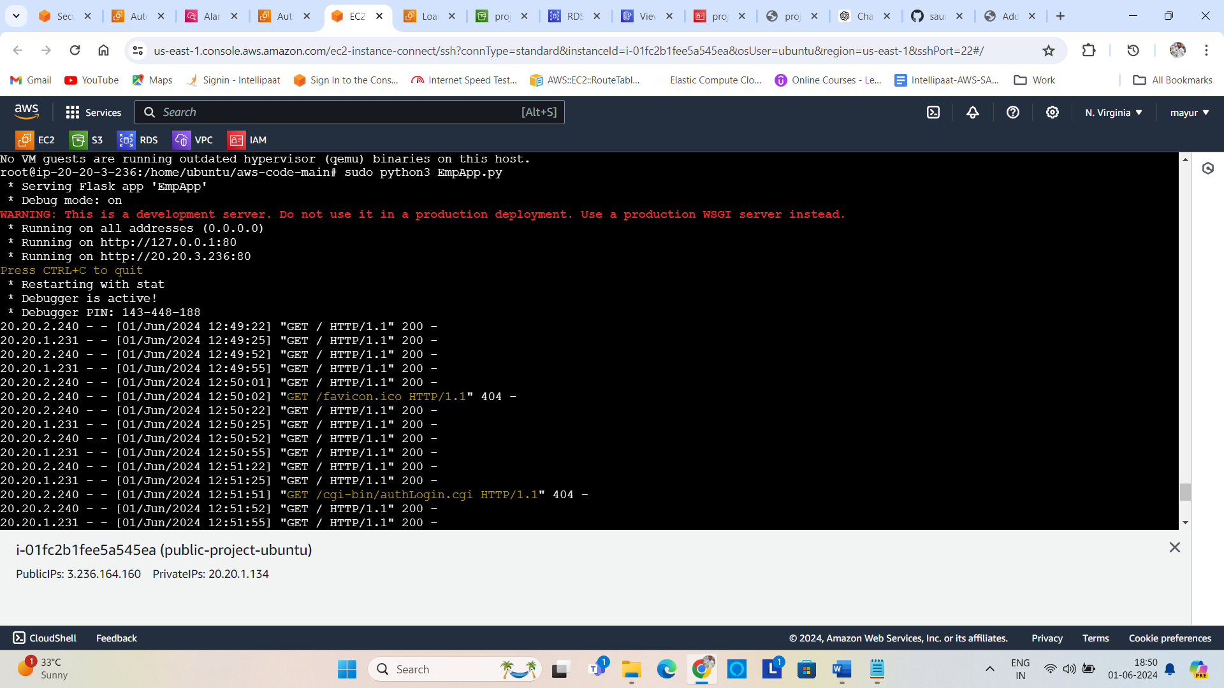

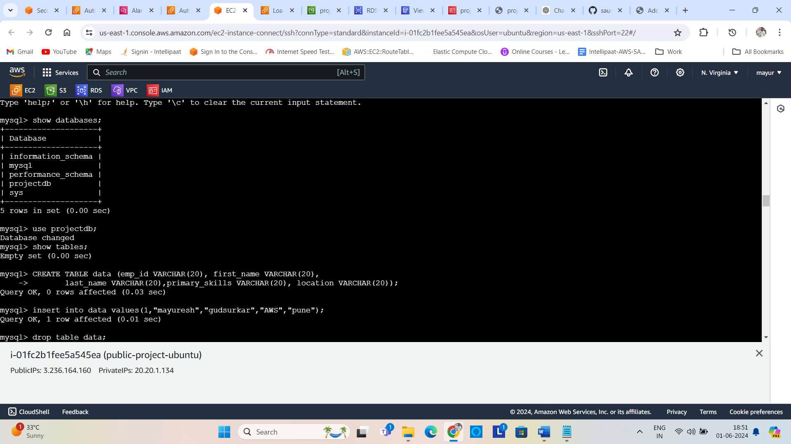

After filling this form well get reply like this   
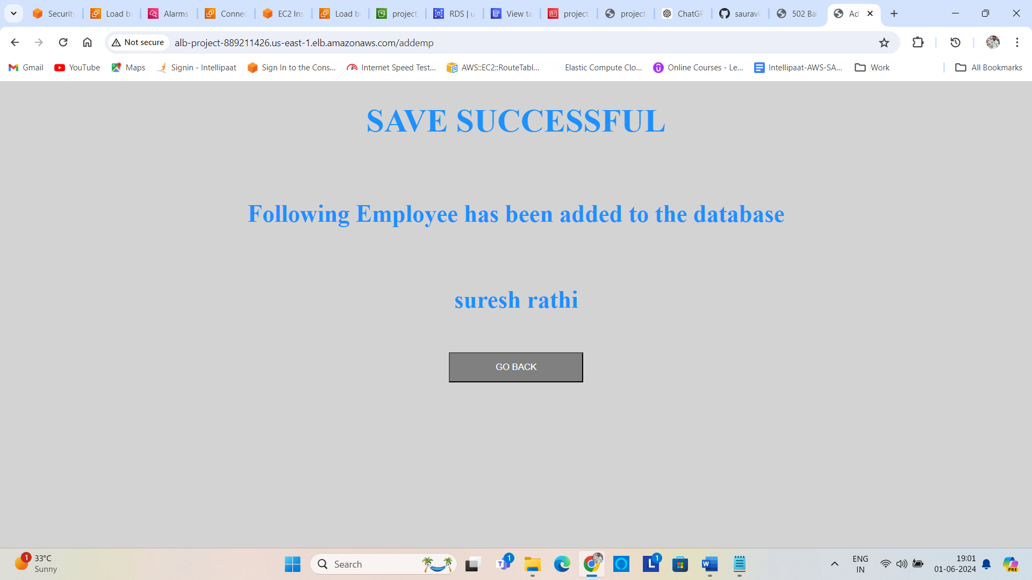

\

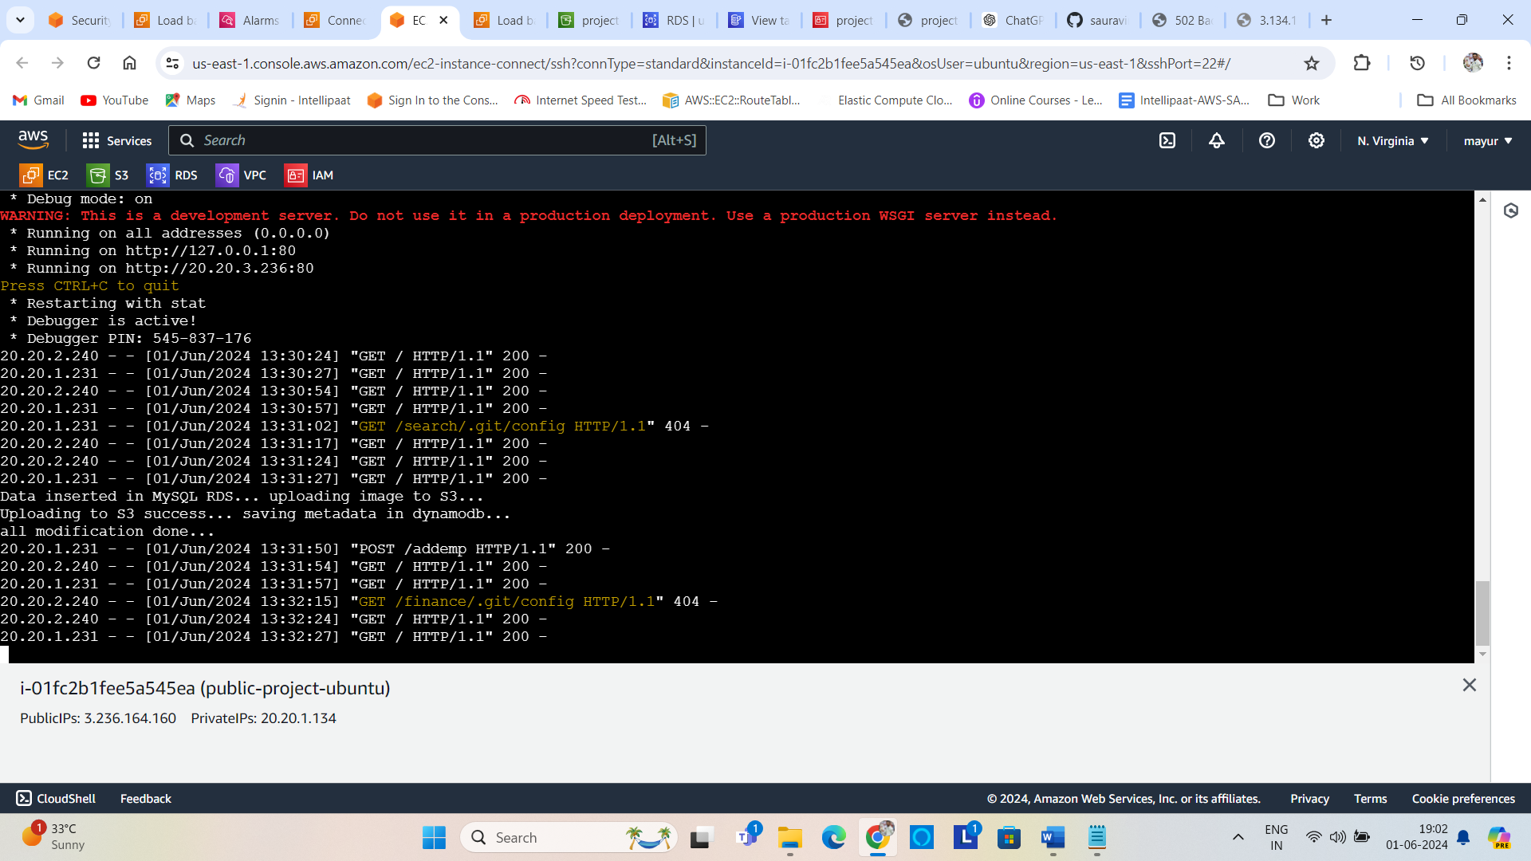

And we can fetch the filled data from from mysql db like this

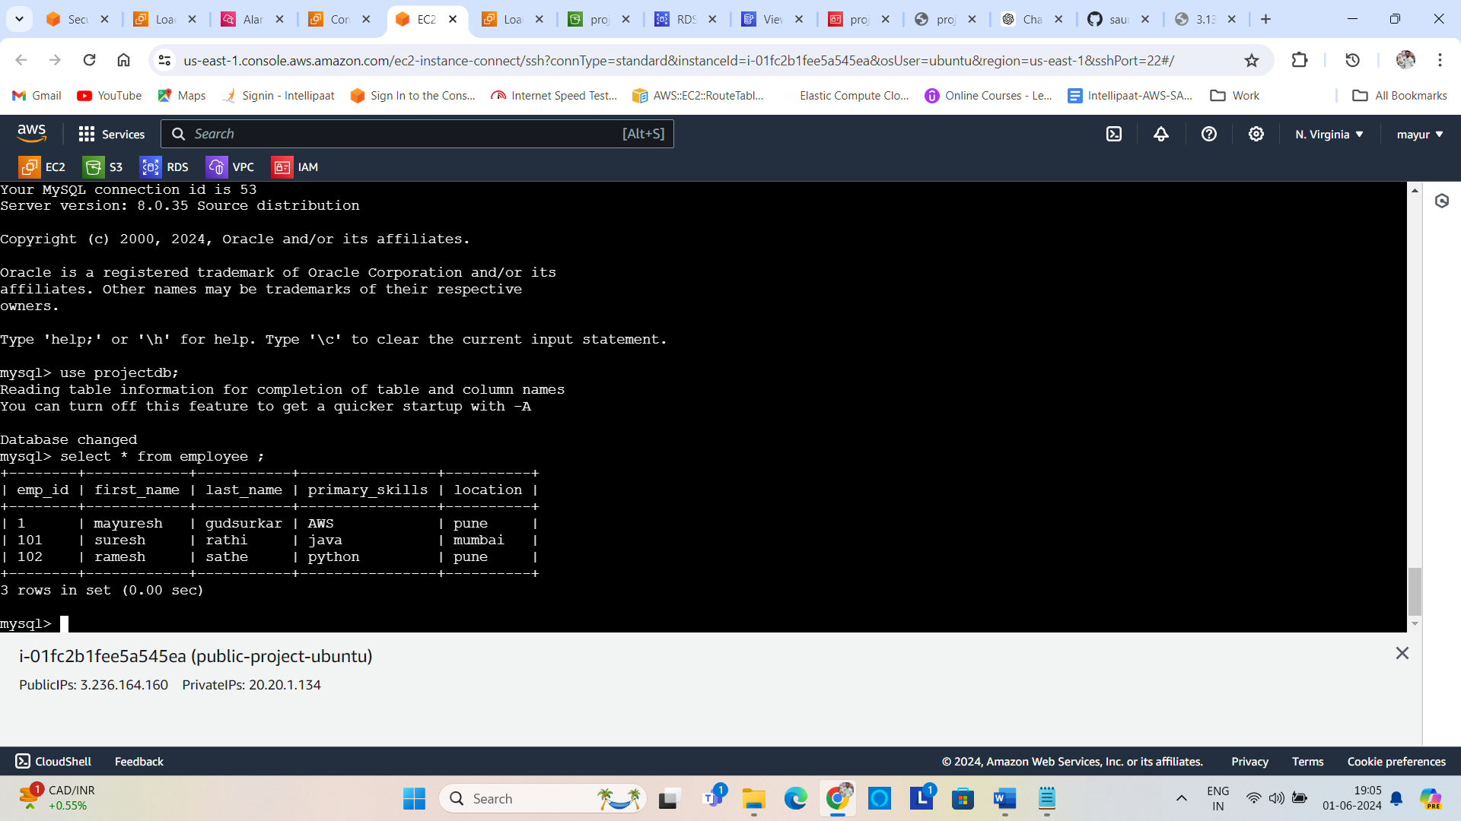

Entries recorded in DynamoDB also.

